

**SEARCH ENGINE OPTIMIZATION**

**PRACTICALS**

Name :- RAJDEEP SINH CHAVDA En. No. :- 21012011167

Branch :- CE Batch :- 7CE-B1

# B. Tech Semester VII (Computer Engineering)

**Nov - Dec 2024**

Submitted to,

Department of Computer Engineering

U.V. Patel College of Engineering Ganpat University, Kherva - 384 012



 CERTIFICATE

This is to certify that Mr. RAJDEEP SINH CHAVDA En No. 21012011167 of B.Tech Semester VII Computer Engineering branch has satisfactorily completed the term work in SearchEngine Optimization (2CEIT78PE8) within four walls of Ganpat University –

U. V. Patel College of Engineering, Ganpat Vidyanagar,Kherva for the academic year July-Dec 2024 as prescribed in the curriculum.

Date of Submission: / /2024

Head of the Department Subject Faculty

**INDEX**

|  |  |  |  |  |
| --- | --- | --- | --- | --- |
| **Sr.**  **No.** | **Name of Practical** | **Date** | **Page No.** | **Signature** |
| 1 | Introduction of SEO and google search algorithms | _/_/24 | 1 |  |
| 2 | Blog creation and content writing, posting and google analytics. | _/_/24 | 5 |  |
| 3 | To experiment and learn google trends - keyword search analysis | _/_/24 | 15 |  |
| 4 | Write a robots.txt file for your blog. | _/_/24 | 26 |  |
| 5 | Creation and submission of sitemap for your blog. | _/_/24 | 32 |  |
| 6 | Analysing website performance and performing on-page optimization techniques. | _/_/24 | 37 |  |
| 7 | To perform the Keyword research and analysis for your blog or website. | _/_/24 | 49 |  |

|  |  |  |  |  |
| --- | --- | --- | --- | --- |
| 8 | To study and practice off-page optimization techniques. | _/_/24 | 54 |  |

**Search Engine Optimization (2CEIT78PE5)**

# Practical-1

## Aim: Introduction of SEO and google search algorithms

**Task-1: Search, read and understand following terms:**

|  |  |  |  |
| --- | --- | --- | --- |
| Alt tags | Keyword Density | Indexing | Search query |
| Anchor text | Title | Link building | SEM |
| Black Hat SEO | Headline Tags | Link Juice | ranking |
| White Hat SEO | Inbound links | Long tail | backlink |
| Keyword | Outbound links | No-follow | SERP |

* **Alt tags:** Alt tags, also known as alt attributes or alt descriptions, are HTML attributes used to provide alternative text for images on a web page. HTML attribute applied to image tags to provide a text alternative for search engines.
* **Keyword Density:** Keyword density tells you how often a search term appears in a text in relation to the total number of words it contains.
* **Indexing:** Indexing is the process by which search engines like Google crawl and store web pages in their databases, making them available for retrieval and display in search engine results when relevant queries are made.
* **Search query:** A search Query is a word or string of words that a search engine user types into the search box to get result.
* **Anchor text:** Anchor text is the visible characters and words that hyperlinks display when linking to another document or location on the web.
* **Black Hat SEO:** Unethical way to get a site ranking higher in search results.
* **Title:** The title, often referred to as the "title tag," is an HTML element that defines the title of a web page.
* **Link building:** Link building is the practice of building one-way hyperlinks (also known as “backlinks”) to a website with the goal of improving search engine visibility.
* **SEM (Search Engine Marketing):** SEM refers to the marketing strategies and techniques used to promote websites in search engine results pages through paid advertising.

**Dev Patel_22012012010**

**Batch: CE_B3 1 | Page**

* **Black Hat SEO:** Black Hat SEO refers to unethical and manipulative SEO practices aimed at gaming search engine algorithms to achieve higher rankings.
* **Headline Tag:** Header tags are an easy way for you to improve any homepage's technical SEO. There are different types of header tags, categorized by numbers, from <h1> to <h6>.
* **Link Juice:** Link juice is a term in SEO that refers to the amount of authority or value that one backlink passes to the website it connects with.
* **Ranking:** Ranking refers to the position of a web page in search engine results for a specific search query.
* **White Hat SEO:** White Hat SEO refers to ethical and legitimate SEO practices that comply with search engine guidelines. It focuses on providing value to users, creating quality content, and following SEO best practices.
* **Inbound links:** Inbound links, also known as backlinks, are hyperlinks from other websites that direct users to your website.
* **Long Tail:** Long-tail keywords contain three or more words. long-tail keywords have a low search volume, competition rate.
* **Backlink:** A backlink is a link created when one website links to another.
* **Keyword:** keyword is a specific word or phrase that users type into search engines when looking for information, products, or services online.
* **Outbound links:** when you include a link to an external site on your blog page or website.
* **No-follow:** The No - follow attribute tells search engines not to follow the outbound link that is being tagged.
* **SERP (Search Engine Results Page):** SERP refers to the page displayed by a search engine in response to a user's search query.

## Task-2: Study the given algorithm of google and prepare a detailedanalysis

**1. Panda (2011)**

Purpose: Panda was designed to improve the quality of search results by targeting low-quality, thin, and duplicate content. Its aim was to provide users with more relevant and valuable content.

Impact: Websites with poor-quality content or excessive ads saw significant drops in rankings, while high-quality and content-rich websites were rewarded with higher rankings.

1. **Penguin (2012):**

Purpose: Penguin primarily focused on combating web spam and manipulative link building practices. It targeted websites that used black hat SEO techniques, such as buying links or participating in link schemes to artificially boost their rankings.

Impact: Websites with spammy backlink profiles or unnatural link patterns experienced severe penalties, causing their rankings to plummet. Websites that followed white hat SEO and had natural backlink profiles benefited from the update.

1. **Hummingbird (2013):**

Purpose: Hummingbird aimed to improve Google's understanding of search queries and the context behind them. It focused on delivering more accurate search results, particularly for complex, conversational, and long-tail queries.

Impact: Hummingbird enabled Google to interpret user intent better, leading to more relevant results and a shift towards semantic search.

**4. Pigeon (2014):**

Purpose: Pigeon was a local search algorithm update that aimed to provide more relevant and accurate local search results. It integrated local search factors with core web search factors.

Impact: Local businesses and directories experienced changes in their local rankings. Websites that had well-optimized local SEO elements and a strong online presence in their target areas benefited from this update.

**5. Mobilegeddon (2015):**

Purpose: Mobilegeddon targeted websites that were not mobile-friendly, promoting the importance of mobile responsiveness in search rankings. It aimed to improve the mobile search experience for users.

Impact: Websites that were not mobile-friendly saw significant drops in mobile search rankings, while mobile-optimized sites gained an advantage in mobile search results.

**6. Possum (2016):**

Purpose: Possum focused on diversifying and refining local search results. It aimed to prevent spam and provide users with a more diverse set of local businesses in the search results.

Impact: Local businesses that were physically located outside the city center saw improved visibility in local searches.

**7. Fred (2017):**

Purpose: Fred targeted websites that violated Google's webmaster guidelines and prioritized revenue generation over user value. It aimed to penalize low-quality, ad heavy, and affiliate-driven content.

Impact: Websites with thin content, excessive ads, and low-value content were penalized, resulting in significant traffic drops.

**8. Bidirectional Encoder representation from transformers (BERT - 2019):**

Purpose: BERT is a natural language processing (NLP) algorithm that helps Google better understand the context and nuances of search queries. It aims to improve the understanding of the intent behind longer and more conversational search phrases.

Impact: BERT has allowed Google to provide more accurate and relevant search results for complex and conversational queries.

# Practical-2

## Aim: Blog creation and content writing, posting and google analytics.

**Prerequisites:** What is blog? Whether to create a blog or not? Benefits? Motivation? Visit this link: [How to Start a Successful Blog in 2021 | The Minimalists](https://www.theminimalists.com/blog/#start-fast-2)

**Task-1:** Think and decide a topic on which you want to create a blog (individually).

Topic: Blogging and SEO

**Task-2:** Which platform to decide? Blogger / WordPress / medium. Visit this [blog to](https://www.stanventures.com/blog/wordpress-blogspot-medium-seo-friendly/) know more about it.

Platform: Blogger

**Task-3:** Content writing guidelines. Know your content gathering techniques and resources. Keep creating and posting the contents regularly in your blog (once in a week at least)

**Task-4:** Add and configure the google analytics add-on to your blog. Monsterinsights official [site](https://www.monsterinsights.com/blog/)

For wordpress:<https://wordpress.org/plugins/google-analytics-for-wordpress/>

For blogger: [Link](https://www.wikihow.com/Add-Google-Analytics-to-Blogger) [https://seobysHarsh1443.blogspot.com/2023/10/hi-here-some-our-](https://seobysharsh1443.blogspot.com/2023/10/hi-here-some-our-recommendations-to-) [recommendations-to-](https://seobysharsh1443.blogspot.com/2023/10/hi-here-some-our-recommendations-to-)

[get.html](https://seobysdivya1443.blogspot.com/2023/10/hi-here-some-our-recommendations-to-get.html)

## When you open Blogger.com - Create a unique and beautiful blog easily. you will have this type of screen in front of you. Now, you need one google account to sign up for blogger once you have one google account you are good to go.



1. 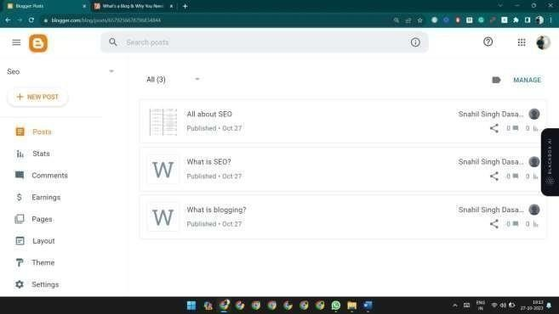**Create your first Blog to analyze the SEO search**

## Post Your First post in the Blog:

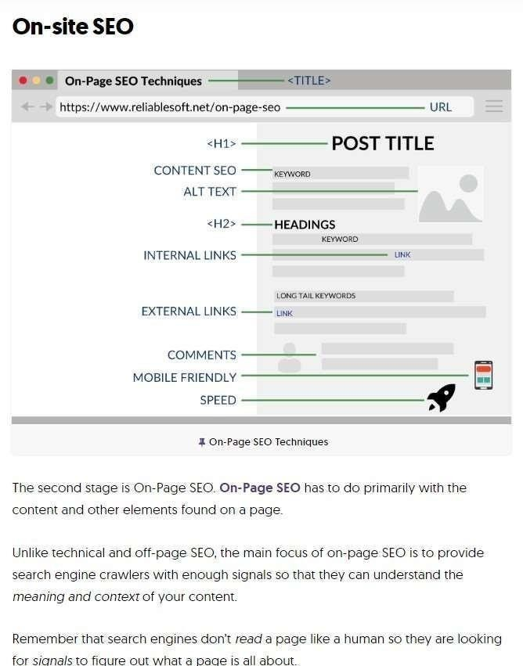

**4 Analytics on Viewing this Your first post in post: last 6 months graph:**

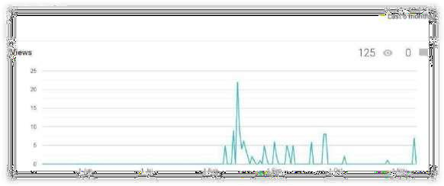

## Top References of this Blog by Search Engine and URLs:

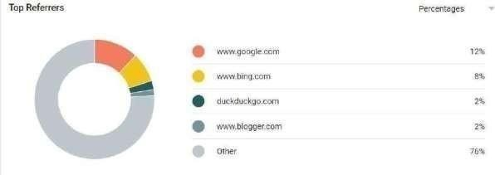

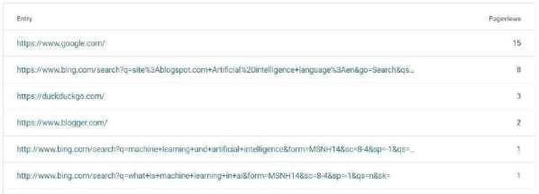

**Audience use which type of browser to view this blog:**

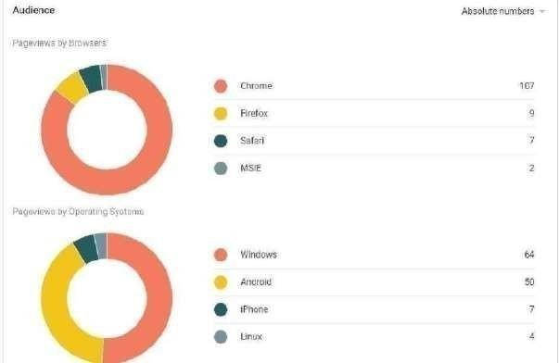

## Which keyword used for search this blog:

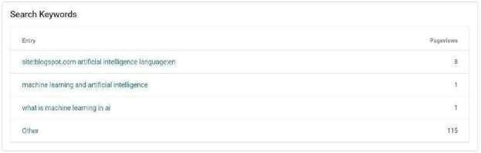

**Location where audience viewing this blog:**

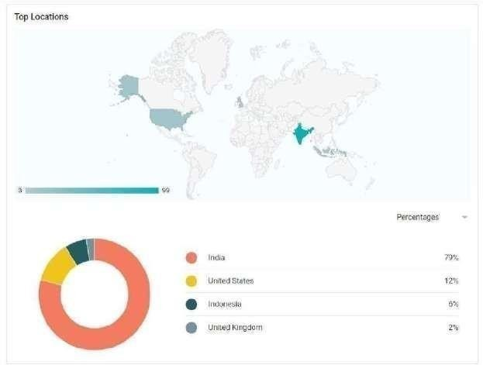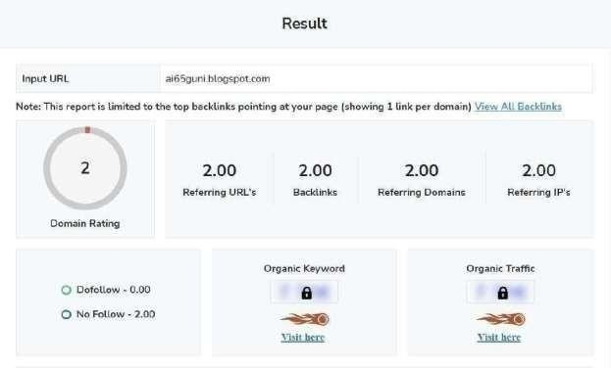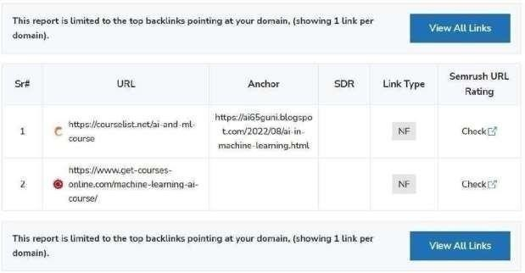

# Practical-3

**Aim: To experiment and learn google trends - keyword search analysis.**

# Perform all the tasks by taking a screenshot of each step and then creating a report of your study.

Explore what the people are searching for.

The google website link is https://trends.google.com/trends/?geo=IN which can help you to know what people are searching for and how many times they have searched not only in a particular time but also in countries wise. We can know what is the trend in the country about lifestyle, food, and games. We also see the Realtime and daily search trends of any country. It identifies which keyword is mostly used.

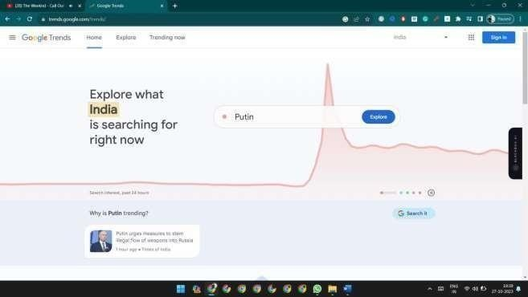

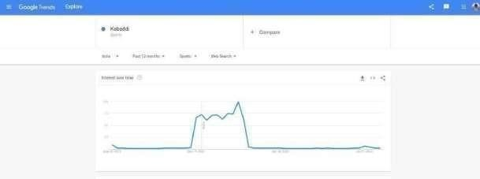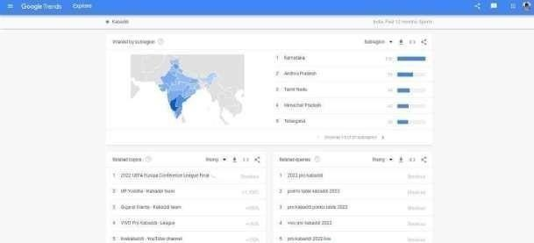

**Tasks:**

1. Find out what is top-10 most searched terms of today (daily search trends / real time search trends / country wise searches)

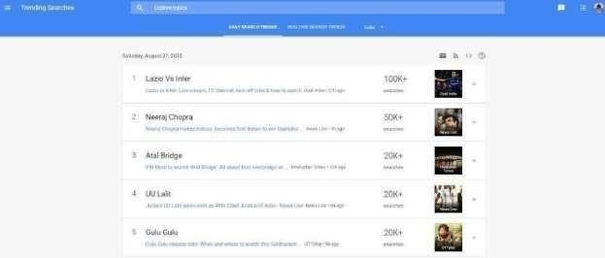

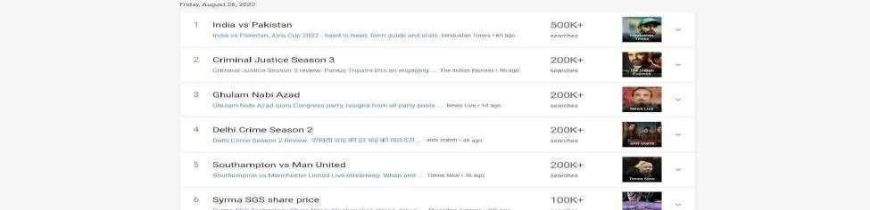

**Real-time Search Trends :**

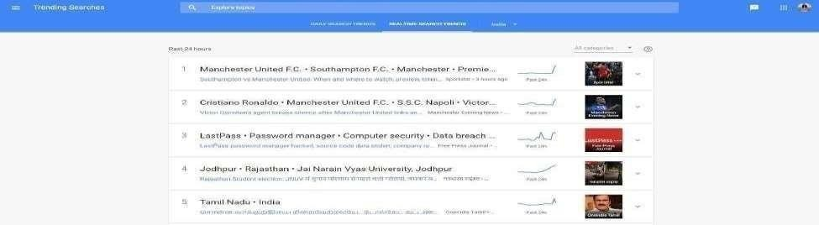

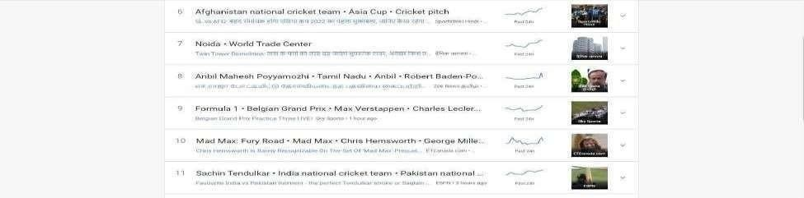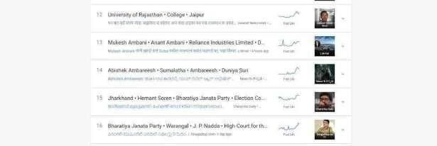

# Country Wise Searches :

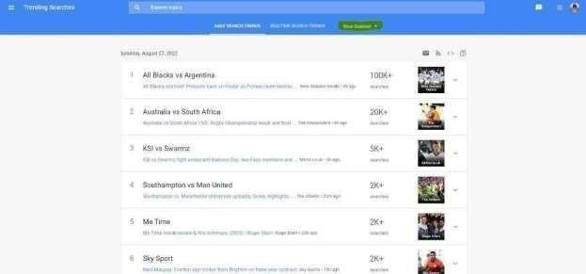

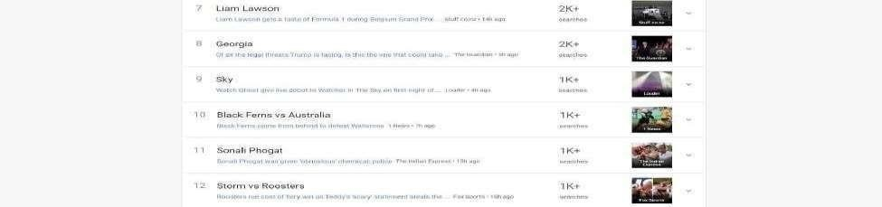

1. Find out the difference between ‘term’ and ‘topic’ for any keyword by comparing its results.

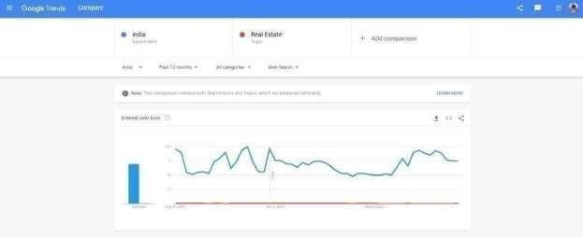

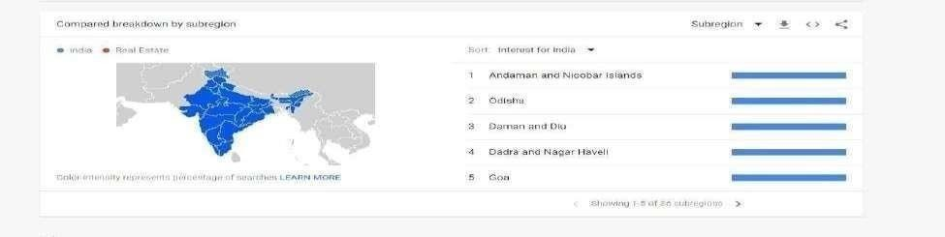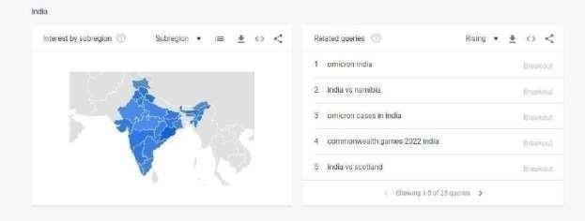

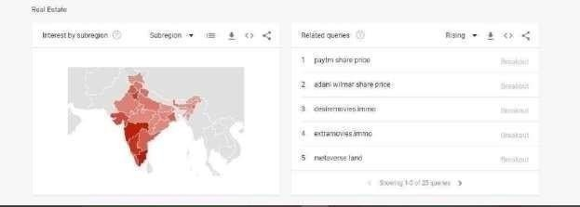

The difference is that topics will include all search terms related to them whereas search terms are specific and results will only show the relative volume of the term. To put it another way, topics are a collection of search terms.

1. Take any four terms and compare its analysis. (test all filters provided by google trends)

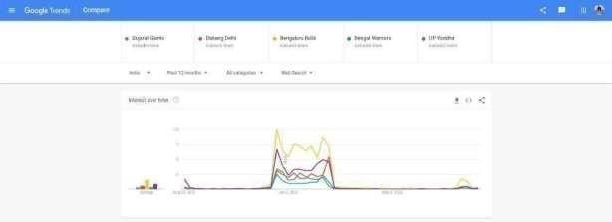

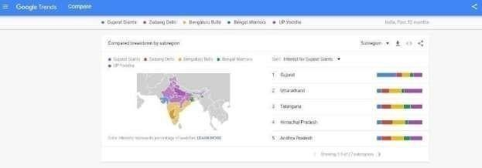

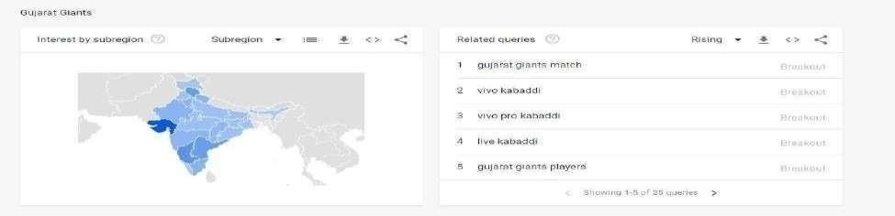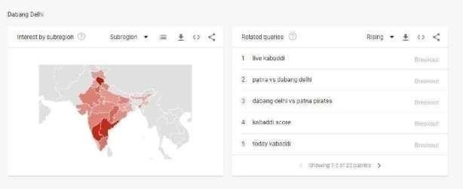

1. Just check, view and analyze the year wise (2020, 2019 and 2018) search results. And provide the answer to the following question: Can you predict at least 5 terms to be searched over google in 2022?

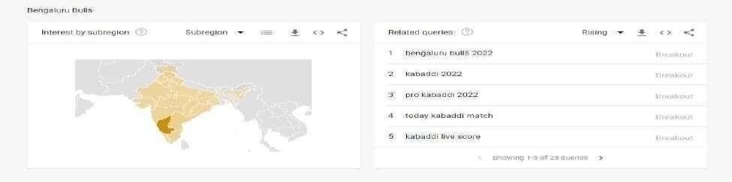

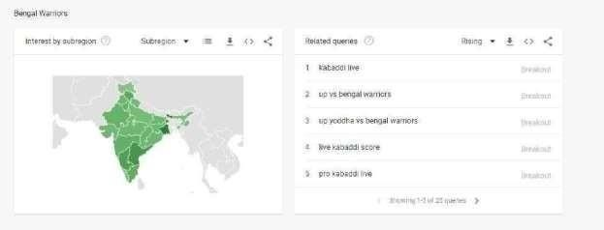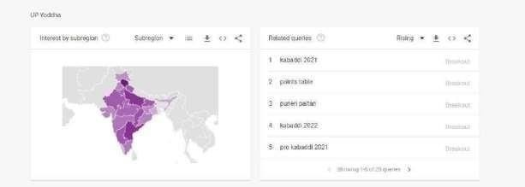



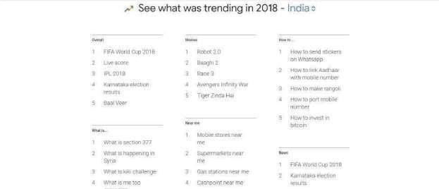

2019:



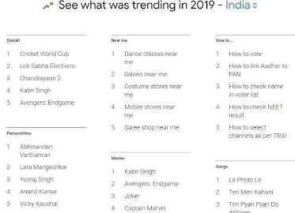

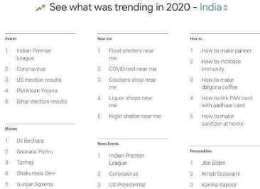2020::

# Practical -4

**Aim: Write a robots.txt file for your blog.**

## Task-1: Know what is robot.txt file and its content for any blog/website.

The robots.txt, or robot exclusion protocol, is a set of web standards that controls how search engine robots crawl every web page, down to the schema markups on that page. It’s a standard text file that can even prevent web crawlers from gaining access to your whole website or parts of it**. How does a robots.txt file look?**

The syntax is simple: you give bots rules by specifying their user-agent and directives.

The file has the following basic format: Sitemap: [URL location of sitemap] User-agent: [bot identifier]

[directive 1]

[directive 2] [directive …]

User-agent: [another bot identifier] [directive 1]

[directive 2] [directive …]

## How to find your robots.txt file

If your website already has a robot.txt file, you can find it by going to this URL: https://yourdomainname.com/robots.txt in your browser. For example, here’s our file.

## How does a Robots.txt file work?

A robots.txt file is a plain text file that does not contain any HTML markup code (hence the .txt extension). This file, like all other files on the website, is stored on the web server. Users are unlikely to visit this page because it’s not linked to any of your pages, but most web crawler bots search for it before crawling the entire website.

A robots.txt file can give bots instructions but can’t enforce those instructions. A good bot, such as a web crawler or a news feed bot, will check the file and follow the instructions before visiting any domain page. But malicious bots will either ignore or process the file to find forbidden web pages.

In a situation when a robots.txt file contains conflicting commands, the bot will use the most specific set of instructions.

## Task-2: Make your own robot.txt file and prepare a report like [this.](https://docs.google.com/document/d/1kaA5bOgZT0G-qYqPTzKR4uLqZhnbRZ3Q/edit?usp=sharing&ouid=109828403771159456177&rtpof=true&sd=true)

**Step 1: Open Your Blog With All posts visible.**

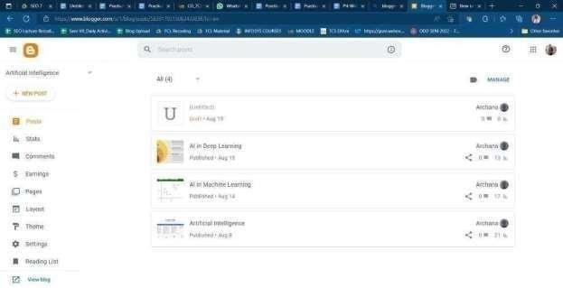

**Step 2: View Blog click and open the blog in a new tab.**

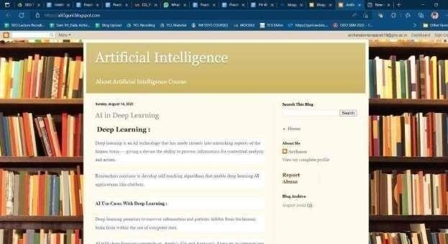

# Step 3: write robots.txt after ‘ / ‘ in the URL of the blog.



## Step 4: Enter and see by default the robots.txt file of your bolg.

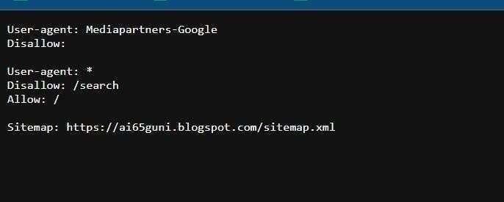

**Step 5: Copy the old content of the robots.txt file and paste into notepad for making a custom robots.txt file.**

## Open setting in blog dashboard and on Crawlers and indexing setting and past new custom robots.txt file and save it.

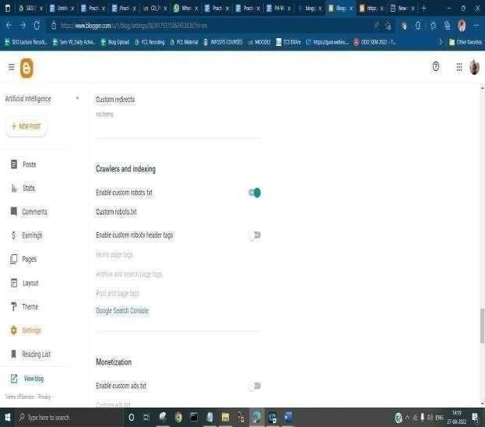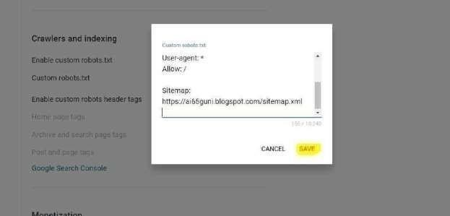

**Step 6 : Reference robots.txt url and see the custom robots.txt file.**

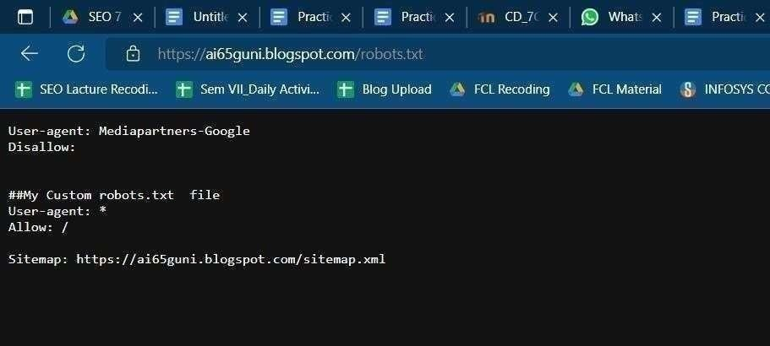

# Practical-5

## Aim: Creation and submission of sitemap for your blog.

Create a sitemap from an online tool. Generate the XML file. Take the screenshots of all of your operations/steps. Then prepare a report.

## Step 1 create a blog with a few posts:

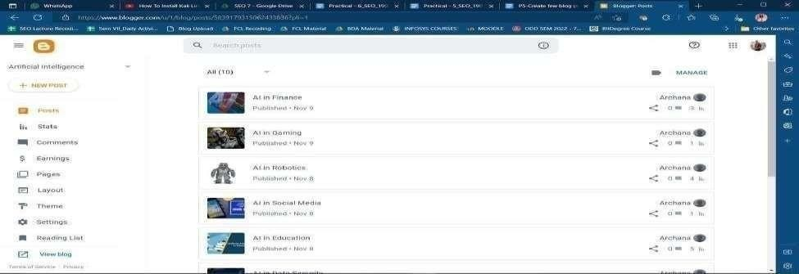

**Step 2 blog screenshot:**



## Step3 create a site map ( from an external site):

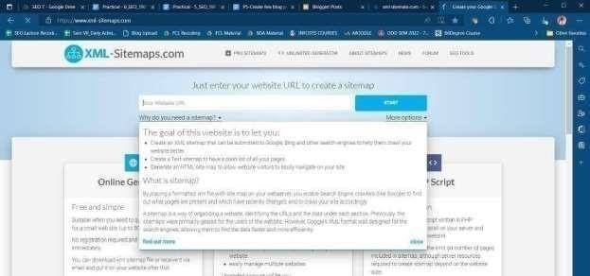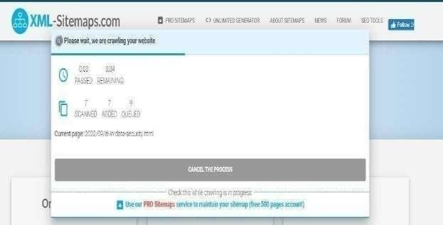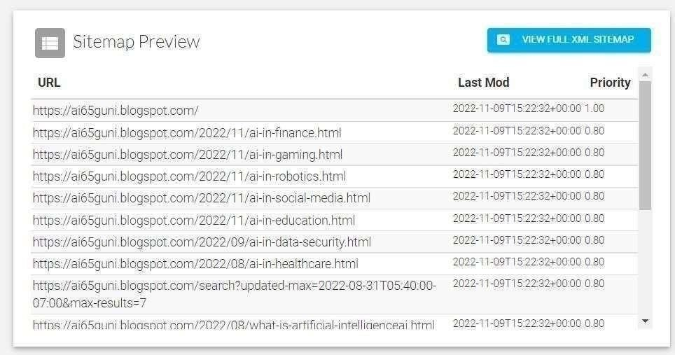

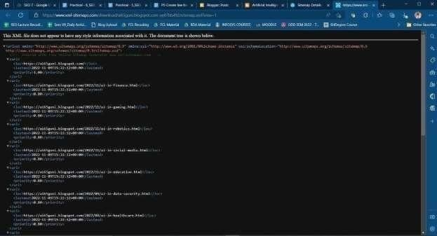

**Step 4 submit site map in Webmaster & Report:**

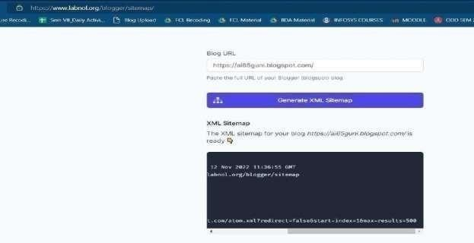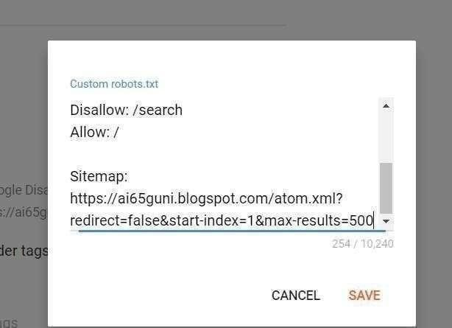

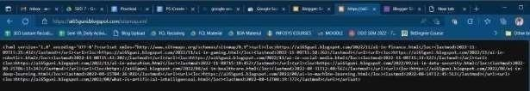

# Practical – 6

## Aim: Analyzing website performance and performing on-page optimization techniques.

Tasks:

1. GTmetrix:
   1. Create a free account (sign up) at gtmetrix.com

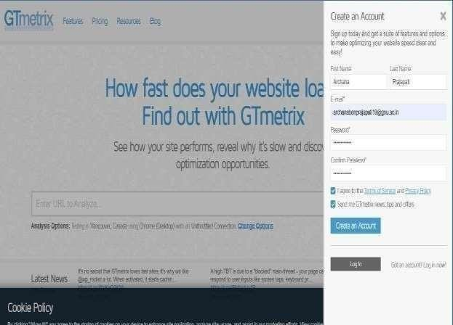

* 1. Use the gtmetrix tool for any website like uvpce.ac.in, dcs,gnu.ac.in or ganpatuniversity.ac.in to test its performance.

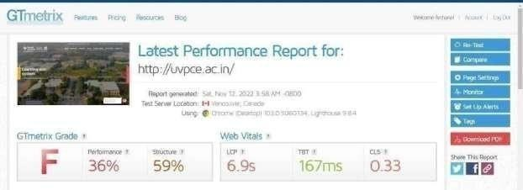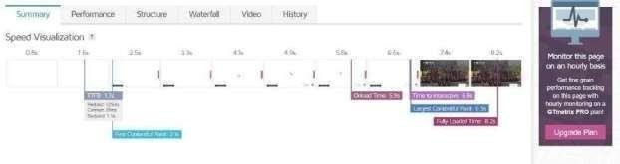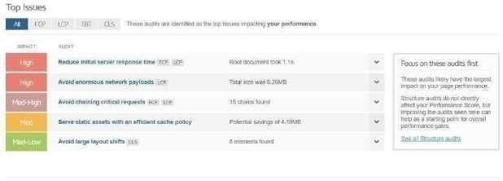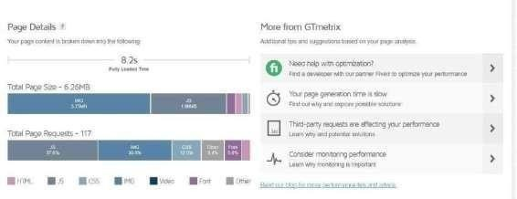

* 1. Analyze the result and Generate a pdf report of it.



* 1. Explain each field/parameter of the generated report.

1. Page speed insights
   1. Use any URL to test in this tool. Analyze its result for mobile and desktop

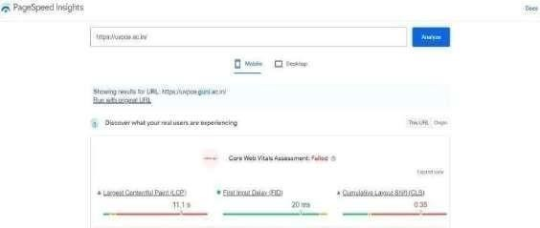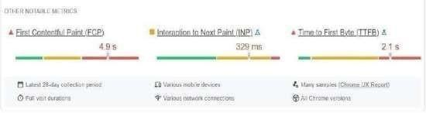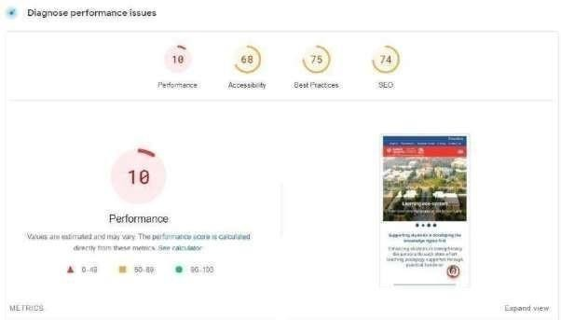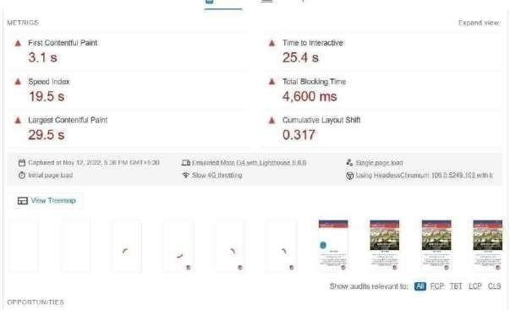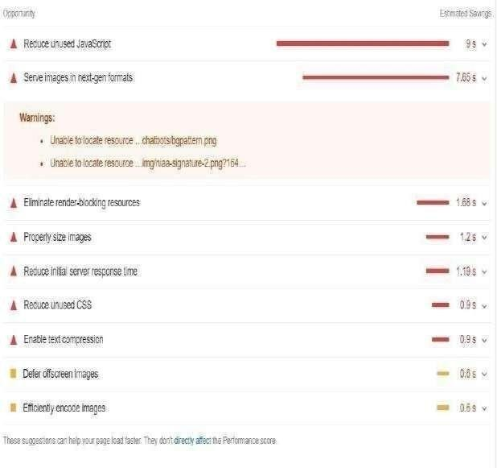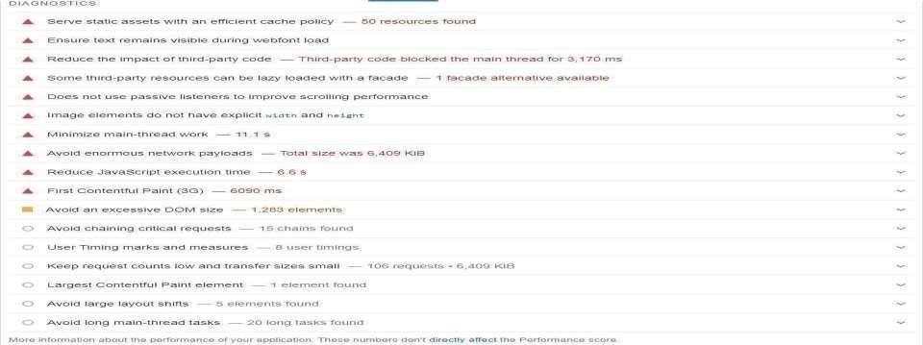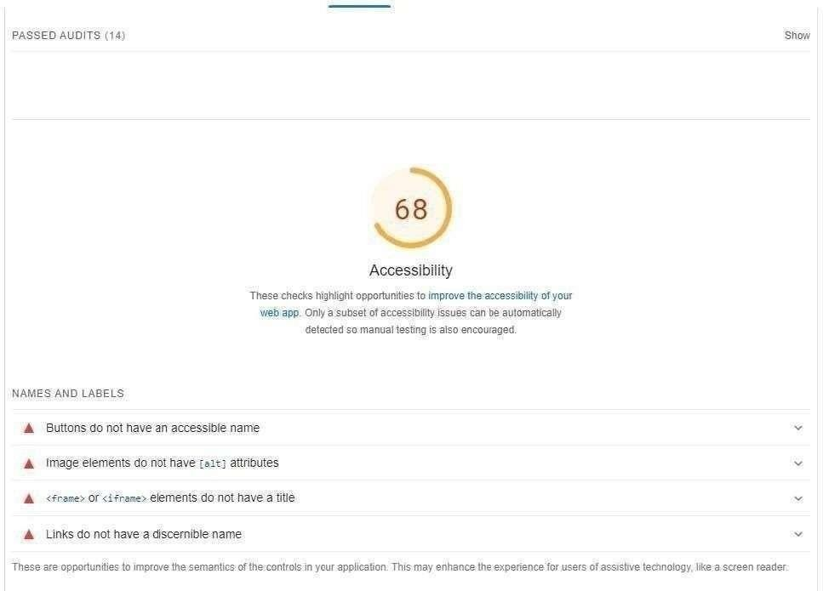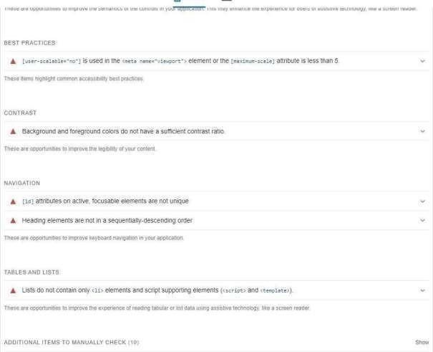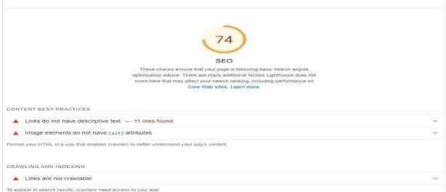

1. **On-page optimization techniques** Explore, experiment, and test the following on-page optimization techniques you know for your blog/website. Take an example of each method to demonstrate.
   1. **Page title**: The page title or post title is nothing but the title which appears as the first thing on the website or webpage. The title can be around 60 to 80 characters limit. And also, make sure your post title always comes with H1 tags. If you cannot update your post title in H1, ask your developers to do so.

## Meta description and keywords:

Meta description: is not a direct SEO ranking factor but it helps in ranking indirectly. It is one of the best places to place our keywords. Meta description helps increase SERPs' click-through rate (CTR).

CTR is again one of the ranking factors in SEO. Most of search engines display the keywords in the description in bold format. Format:

<meta name=”description” content=”your meta description goes here”>

Meta Keywords: Meta keywords are the place where we can update our targeting keywords. 3 to 4 keywords are suggestible. Few experts do not bother about the usage of meta keywords. Meta keywords are the least priority in ranking factors in SEO. But my opinion is, every single thing must matter to us if we really want to beat the competition. Format:

<meta name=”keywords” content=”keyword 1, keyword 2, keyword 3″/>

* 1. Meta tags:

Meta tags are snippets of code that tell search engines important information about your web page, such as how they should display it in search results. They also tell web browsers how to display it to visitors.

* 1. 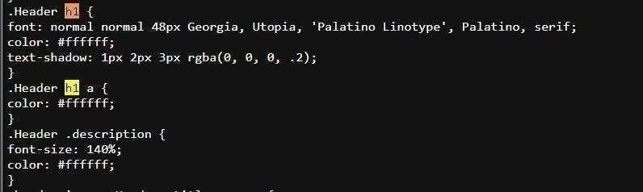Headings <h1>...<h6>:

The ‘H’ in H1, H2 and H3 stands for Heading. Every blog/post can be given three headings. The first heading or title of the blog is automatically assigned H1. You can use H2 for the side-headings of your post. And H3 is for sub-headings, if any, on the post. Make sure to use all the three types for better credibility.

* 1. Bold, italics, underlined text:

Bold:

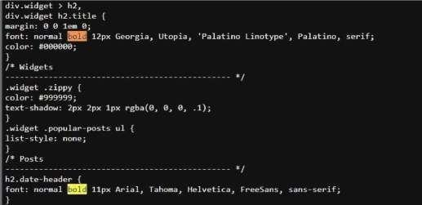

The bold option is useful when you want to highlight the important words/sentences of your content. Make sure you use this option wisely because of the words that are made bold catch the viewers’ attention more quickly than the normal words.

Italic

If there are important keywords in your answer that you want the users to see or if there

are catchy sentences that you want them to check, then you can use the italic option to italicize that particular word/sentence, thus making it easier for them to locate.

* 1. Domain name suggestion:

Artificial Intelligence (ai65guni.blogspot.com)

When starting a new website, one of the most important decisions you have to make is choosing the right domain name. For many years, SEO strategists have devised many practices to help gain higher rankings on search engines and domain names is a factor that is believed to play a part in the SEO game.

* 1. 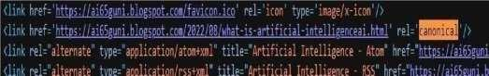Canonical tags:

A canonical tag (rel=“canonical”) is a snippet of HTML code that defines the main version for duplicate, near-duplicate and similar pages. In other words, if you have the same or similar content available under different URLs, you can use canonical tags to specify which version is the main one and thus, should be indexed.

* 1. Images and alt tags:



Alt text or SEO alt tags are the words behind the image. In other words, search engines need to read code in order to understand what something is. The engine cannot physically see the image, thus alt text acts as the code, a way for marketers to tell the

computer what it is viewing. This enables the search engine to better rank pages when it comes to their on-page SEO result.

# Practical-7

## Aim: To perform the Keyword research and analysis for your blog or website

**Task-1:**

keyword listing and show competition per keyword with its CPC using google adwords. Refer this [Link](https://docs.google.com/document/d/1gNVxvp-LUTXCDHnuMT3QgE2m1aG1KnpO/edit?usp=sharing&ouid=109828403771159456177&rtpof=true&sd=true) [to](https://docs.google.com/document/d/1gNVxvp-LUTXCDHnuMT3QgE2m1aG1KnpO/edit?usp=sharing&ouid=109828403771159456177&rtpof=true&sd=true) know the steps to follow.

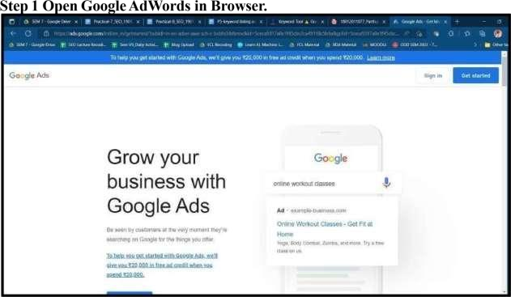

## Step 2 After Login in Google Ads view the below homepage:

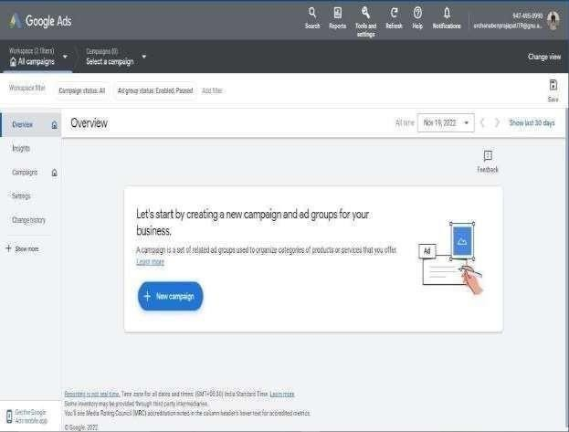

**Step 3 Keyword Planner Tool Page in Adword:**

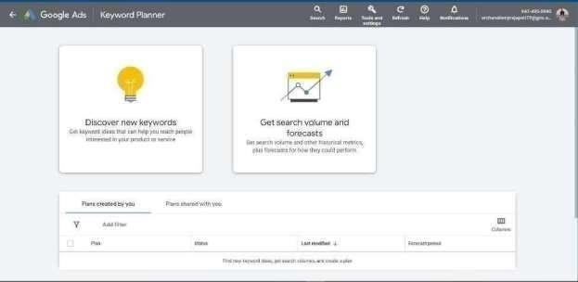

## Step 4 Discover new keywords:

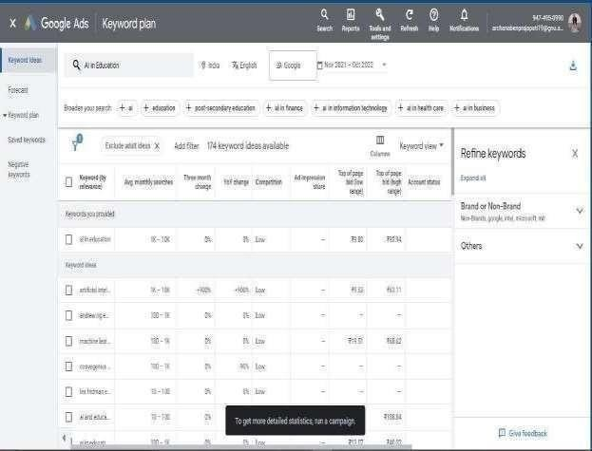

**Step 5 Get search volume and forecasts:**

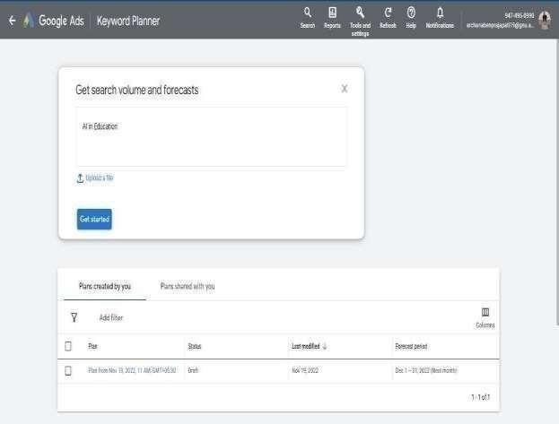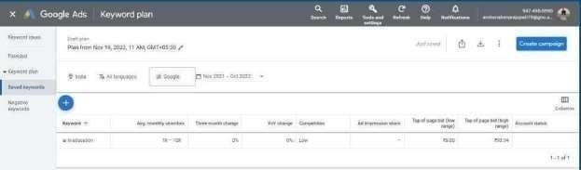

**Task-2:**

Show the steps to do the same using <https://keywordtool.io/>

## Step 1 Visit Keywordtool.io Website for Keyword research and analysis:

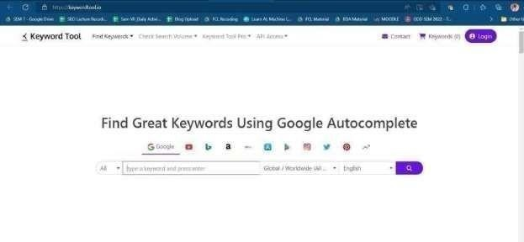

**Step 2 Serch keyword in this site:**

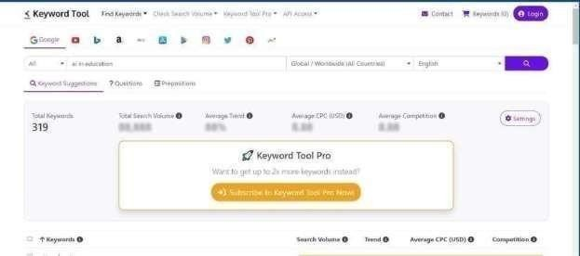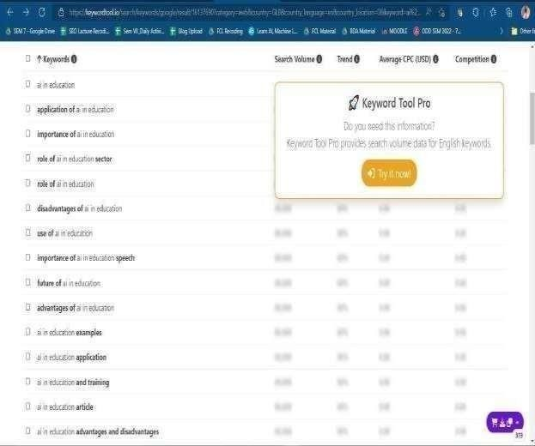

# Practical-8

## Aim: To study and practice off-page optimization techniques.

Perform off page optimization using following techniques for your blog/website you created earlier.

- Document Sharing / Image sharing

Document sharing is another off-Page SEO Technique. By sharing content related to your brand on different platforms, you'll have the option to rank for keywords your website wouldn't otherwise capable of completing for different reasons, like the competition is excessively high. If you figure out that your piece of content would serve others' advantage too, upload documents to doc sharing websites such as SlideShare, Academia, and Scribd.

The document is treated as a conventional piece of content- perform keyword research and completely optimize them: transcripts, file name, titles. Put viable call-to-action and links back to your site at whatever point is significant and possible.

The advantage of posting a document on such a platform are that PowerPoint and PDF files cannot be crawled by search engines, but these sites help them make it readable. Besides this, you borrow several link juice for your site, which is furthermore, great.

**Document Sharing:**

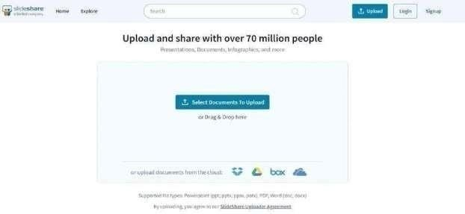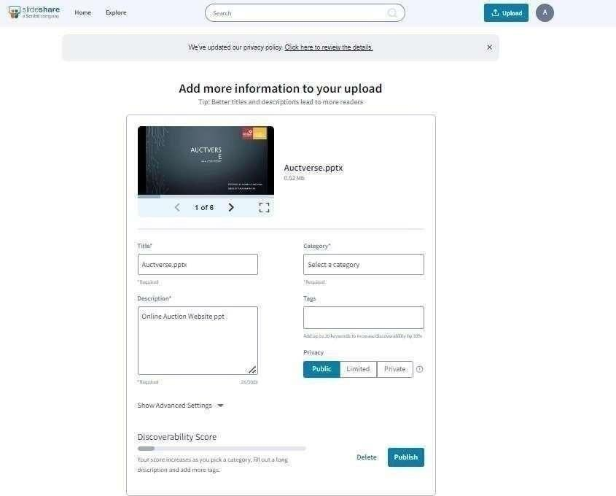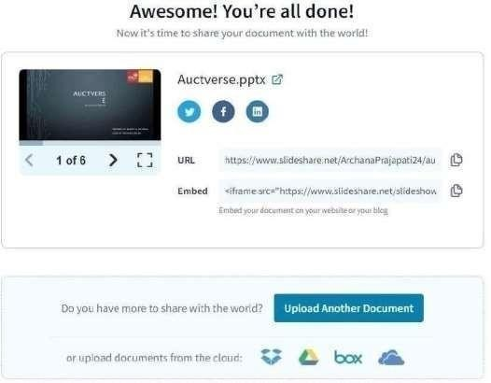

**Image Sharing:**

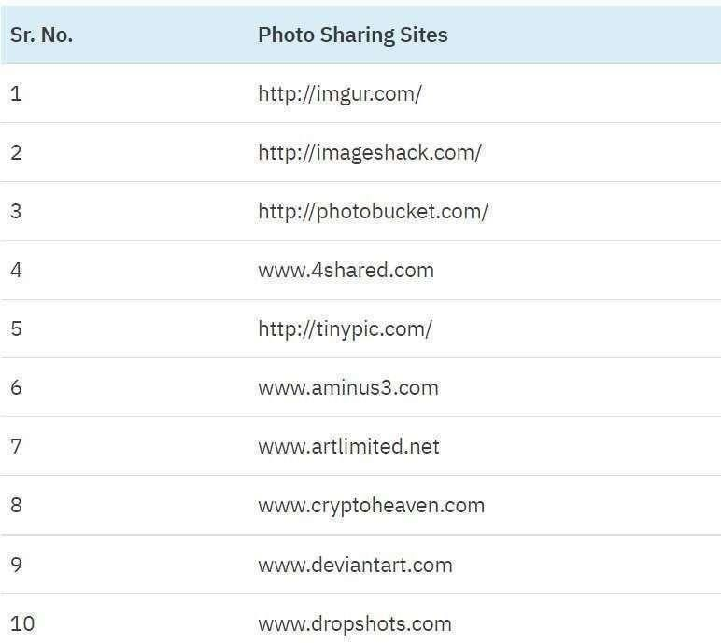

|  |  |  |
| --- | --- | --- |
| - | Social bookm | ark submission / engagements |

* Social bookmarking sites are one of the best platforms to promote your website. When you bookmark your webpage or blog post on popular social bookmarking websites, you gain high traffic to your webpage or blog.

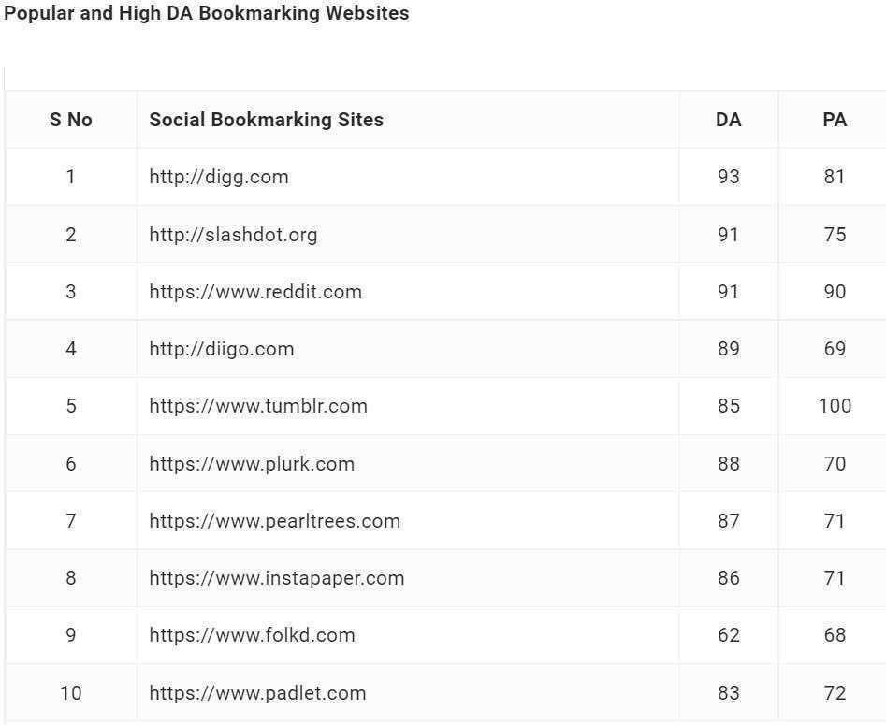

* Guest post submission

Guest posting can help you get your business in front of a targeted audience, deliver targeted traffic, and represent yourself as an expert in your subject.

And in reality, links should be one of many reasons for guest posting; they should only be an advantage if they occur.

The main goal of guest posting should be to attract a new audience, get in front of the traffic of a comparable site, and approach the strategy with this perspective, and you will discover that it's beneficial.

* Forum Discussion
* Participate in search forums which are related to your website and business and make a connection with that community. Reply to threads, answer people’s questions and give your suggestions and advice.

Make use of

* “DoFollow” forums. Forum submission an outdated off-page seo technique, - however you can try to get a few links from relevant forums.

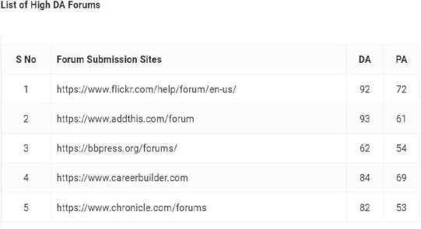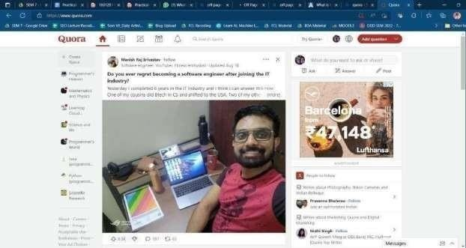

* Back link creation

Backlinks are one of the major factors in ranking any webpage. In other words, backlinks give an indication to search engines about the authority of any webpage or website.

For Example, Two Players of the same potential are going for a selection in an Indian cricket team. One has a reference of Sachin Tendulkar and the other one does not have any reference. The answer is obvious: a player who is referred to by Sachin Tendulkar will be selected.

In the same way, backlinks help your webpage in ranking in search result pages. Backlinks/ References

work as a trust factor and help search engines

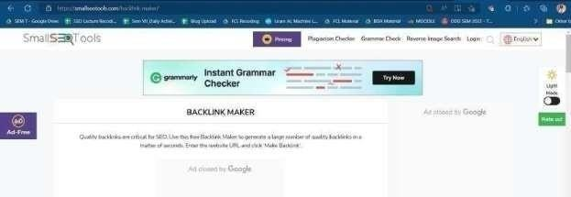

to rank any webpage in search results.

-

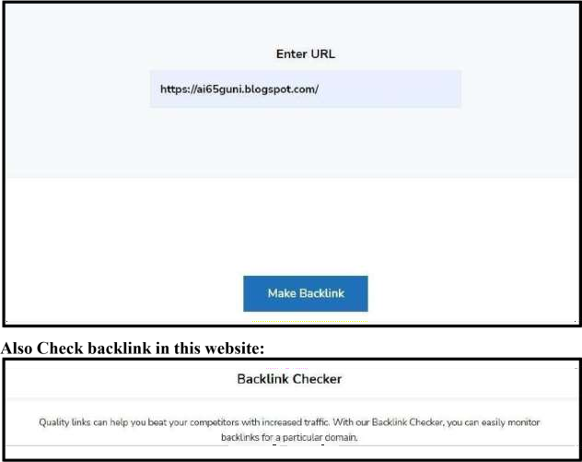



Suggestion: Watch this video <https://www.youtube.com/watch?v=vWEo_SOqZfA>

Take proper screenshots of every step and use it in your report.